# TEGNIESE WISKUNDE V2

# NOVEMBER 2024

# NASIONALE

# SENIOR SERTIFIKAAT



# GRAAD 12

**PUNTE: 150**

# TYD: 3 uur

**Hierdie vraestel bestaan uit 15 bladsye en 'n 2 bladsy-inligtingsblad.**

|  |  |  |
| --- | --- | --- |
| **INSTRUKSIES EN INLIGTING** |  |  |

|  |  |  |
| --- | --- | --- |
| Lees die volgende instruksies noukeurig deur voordat die vrae beantwoord word. |  |  |

|  |  |  |  |
| --- | --- | --- | --- |
| 1. | Hierdie vraestel bestaan uit 11 vrae. |  |  |

|  |  |  |  |
| --- | --- | --- | --- |
| 2. | Beantwoord AL die vrae in die SPESIALE ANTWOORDEBOEK wat verskaf word. |  |  |

|  |  |  |  |
| --- | --- | --- | --- |
| 3. | Dui ALLE berekeninge, diagramme, grafieke, ens., wat jy gebruik het om jou antwoorde te bepaal, duidelik aan. |  |  |

|  |  |  |  |
| --- | --- | --- | --- |
| 4. | Volpunte sal NIE noodwendig aan slegs antwoorde toegeken word NIE. |  |  |

|  |  |  |  |
| --- | --- | --- | --- |
| 5. | Indien nodig, rond antwoorde tot TWEE desimale plekke af, tensy anders vermeld. |  |  |

|  |  |  |  |
| --- | --- | --- | --- |
| 6. | Diagramme is NIE noodwendig volgens skaal geteken NIE. |  |  |

|  |  |  |  |
| --- | --- | --- | --- |
| 7. | Jy mag 'n goedgekeurde, wetenskaplike sakrekenaar (nieprogrammeerbaar en niegrafies) gebruik, tensy anders vermeld. |  |  |

|  |  |  |  |
| --- | --- | --- | --- |
| 8.  9. | 'n Inligtingsblad met formules is aan die einde van hierdie vraestel ingesluit.  Skryf netjies en leesbaar. |  |  |

|  |  |  |
| --- | --- | --- |
| **VRAAG 1** |  |  |

|  |  |  |
| --- | --- | --- |
| Die diagram hieronder toon ABC met hoekpunte ,  en .  CA is verleng om die inklinasiehoek, , met die positiewe *x-*as te vorm.  M is die middelpunt van AC. Nov |  |  |
|  |  |  |

|  |  |  |  |
| --- | --- | --- | --- |
| 1.1 | Bepaal die gradiënt van AC. |  | (2) |

|  |  |  |  |
| --- | --- | --- | --- |
| 1.2 | Bepaal vervolgens die grootte van hoek . |  | (2) |

|  |  |  |  |
| --- | --- | --- | --- |
| 1.3 | Bepaal die lengte van BC. |  | (2) |

|  |  |  |  |
| --- | --- | --- | --- |
| 1.4 | Bepaal die koördinate van M. |  | (2) |

|  |  |  |  |
| --- | --- | --- | --- |
| 1.5 | Bepaal die vergelyking van die lyn deur M, loodreg op AC, in die vorm *y* = … |  | (4) |
|  |  |  | **[12]** |

|  |  |  |
| --- | --- | --- |
| **VRAAG 2** |  |  |

|  |  |  |  |
| --- | --- | --- | --- |
| 2.1 | In die diagram hieronder is O die middelpunt van die sirkel gedefinieer deur  PR is 'n raaklyn aan die sirkel by punt P.  Punt S is 'n *x-*afsnit van die sirkel.  Punt R is die *y*-afsnit van lyn PR. |  |  |

|  |  |  |  |  |
| --- | --- | --- | --- | --- |
|  | 2.1.1 | Bepaal die vergelyking van die sirkel. |  | (2) |

|  |  |  |  |  |
| --- | --- | --- | --- | --- |
|  | 2.1.2 | Skryf die koördinate van S neer. |  | (2) |

|  |  |  |  |  |
| --- | --- | --- | --- | --- |
|  | 2.1.3 | Bepaal die vergelyking van die raaklyn in die vorm *y* = … |  | (4) |

|  |  |  |  |  |
| --- | --- | --- | --- | --- |
|  | 2.1.4 | Skryf die *y*-koördinaat van punt R neer. |  | (1) |

|  |  |  |  |
| --- | --- | --- | --- |
| 2.2 | Gegee: |  |  |

|  |  |  |  |  |
| --- | --- | --- | --- | --- |
|  | 2.2.1 | Druk die vergelyking in die vorm  uit. |  | (1) |

|  |  |  |  |  |
| --- | --- | --- | --- | --- |
|  | 2.2.2 | Skets vervolgens die grafiek van die ellips. |  | (2) |
|  |  |  |  | **[12]** |

|  |  |  |
| --- | --- | --- |
| **VRAAG 3** |  |  |

|  |  |  |  |
| --- | --- | --- | --- |
| 3.1 | Gegee:  rad en  Gebruik 'n sakrekenaar om die volgende te bepaal: |  |  |

|  |  |  |  |  |
| --- | --- | --- | --- | --- |
|  | 3.1.1 | Herlei  rad na grade. |  | (1) |

|  |  |  |  |  |
| --- | --- | --- | --- | --- |
|  | 3.1.2 |  |  | (2) |

|  |  |  |  |  |
| --- | --- | --- | --- | --- |
|  | 3.1.3 |  |  | (2) |

|  |  |  |  |
| --- | --- | --- | --- |
| 3.2 | In die diagram hieronder is  'n punt in 'n Kartesiese vlak.  en  is 'n inklinasiehoek. |  |  |

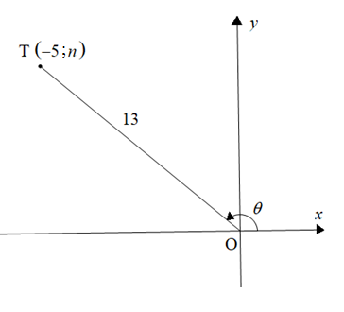

|  |  |  |  |
| --- | --- | --- | --- |
|  | **Sonder die gebruik van 'n sakrekenaar**, bepaal die waarde van die volgende: |  |  |

|  |  |  |  |  |
| --- | --- | --- | --- | --- |
|  | 3.2.1 |  |  | (1) |

|  |  |  |  |  |
| --- | --- | --- | --- | --- |
|  | 3.2.2 |  |  | (4) |

|  |  |  |  |
| --- | --- | --- | --- |
| 3.3 | Bepaal die waarde(s) van *x* indien  vir |  | (4) |
|  |  |  | **[14]** |

|  |  |  |
| --- | --- | --- |
| **VRAAG 4** |  |  |

|  |  |  |  |
| --- | --- | --- | --- |
| 4.1 | Vereenvoudig die volgende: |  |  |

|  |  |  |  |  |
| --- | --- | --- | --- | --- |
|  | 4.1.1 |  |  | (1) |

|  |  |  |  |  |
| --- | --- | --- | --- | --- |
|  | 4.1.2 |  |  | (1) |

|  |  |  |  |  |
| --- | --- | --- | --- | --- |
|  | 4.1.3 |  |  | (6) |

|  |  |  |  |
| --- | --- | --- | --- |
| 4.2 | Beantwoord die volgende vrae: |  |  |

|  |  |  |  |  |
| --- | --- | --- | --- | --- |
|  | 4.2.1 | Voltooi die identiteit: |  | (1) |

|  |  |  |  |  |  |
| --- | --- | --- | --- | --- | --- |
|  | 4.2.2 | Bewys vervolgens dat |  | (4) | |
|  |  |  |  | | **[13]** |

|  |  |  |
| --- | --- | --- |
| **VRAAG 5** |  |  |
|  |  |  |
| Gegee die funksies gedefinieer deur  en  vir |  |  |

|  |  |  |  |
| --- | --- | --- | --- |
| 5.1 | Skets die grafieke van *f* en *g* op dieselfde assestelsel op die rooster wat voorsien is. Dui duidelik ALLE asimptote, afsnitte met die asse en draaipunte aan. |  | (6) |

|  |  |  |  |
| --- | --- | --- | --- |
| 5.2 | Gebruik jou grafieke om die volgende neer te skryf: |  |  |

|  |  |  |  |  |
| --- | --- | --- | --- | --- |
|  | 5.2.1 | Die periode van *g* |  | (1) |

|  |  |  |  |  |
| --- | --- | --- | --- | --- |
|  | 5.2.2 | TWEE waardes van *x* waarvoor |  | (2) |

|  |  |  |  |  |
| --- | --- | --- | --- | --- |
|  | 5.2.3 | Die amplitude van |  | (1) |

|  |  |  |  |  |
| --- | --- | --- | --- | --- |
|  | 5.2.4 | Die resultante (nuwe) vergelyking *h*, indien:   * Die periode van *g* gehalveer is, en * Die waardeversameling  is |  | (2) |

|  |  |  |  |
| --- | --- | --- | --- |
|  |  |  | **[12]** |

|  |  |  |
| --- | --- | --- |
| **VRAAG 6** |  |  |

|  |  |  |
| --- | --- | --- |
| In die diagram hieronder is T, R en N punte in dieselfde horisontale vlak.    Die hoogtehoek van P vanaf R is .  en |  |  |

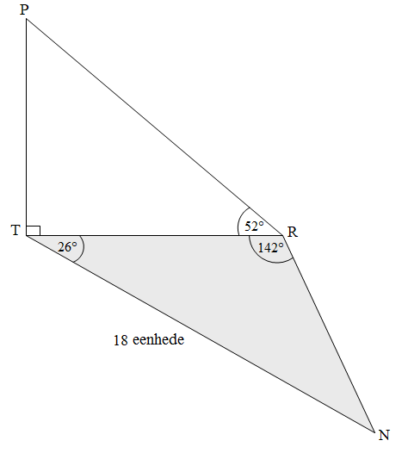

|  |  |  |  |
| --- | --- | --- | --- |
| 6.1 | Skryf die grootte van hoek N neer. |  | (1) |

|  |  |  |  |
| --- | --- | --- | --- |
| 6.2 | Bepaal die lengte van TR. |  | (3) |

|  |  |  |  |
| --- | --- | --- | --- |
| 6.3 | Bepaal vervolgens die lengte van PT. |  | (2) |

|  |  |  |  |
| --- | --- | --- | --- |
| 6.4 | Bepaal: |  | (5) |
|  |  |  | **[11]** |

|  |  |  |
| --- | --- | --- |
| **Gee redes vir jou bewerings in VRAAG 7, 8 en 9.** |  |  |

|  |  |  |
| --- | --- | --- |
| **VRAAG 7** |  |  |

|  |  |  |
| --- | --- | --- |
| In die diagram hieronder is O die middelpunt van die sirkel ABCD.  AOM is 'n reguitlyn.  M is die middelpunt van koord DC. |  |  |

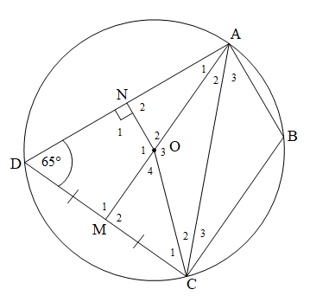

|  |  |  |  |
| --- | --- | --- | --- |
| 7.1 | Skryf die rede neer waarom |  | (1) |

|  |  |  |  |
| --- | --- | --- | --- |
| 7.2 | Skryf vervolgens die rede neer waarom DMON 'n koordevierhoek is. |  | (1) |

|  |  |  |  |
| --- | --- | --- | --- |
| 7.3 | Voltooi die volgende tabel: |  |  |

|  |  |  |  |  |
| --- | --- | --- | --- | --- |
|  | **BEWERING** | **REDE** |  |  |
|  |  | Teenoorstaande ∠e van koordevierhoek |  | (1) |
|  |  | Teenoorstaande ∠e van koordevierhoek |  | (1) |
|  | DN = … | … |  | (2) |

|  |  |  |  |
| --- | --- | --- | --- |
| 7.4 | Bewys, met redes, dat . |  | (3) |

|  |  |  |  |
| --- | --- | --- | --- |
| 7.5 | Toon, met redes, dat AOCB nie 'n koordevierhoek is nie. |  | (3) |
|  |  |  | **[12]** |

|  |  |  |
| --- | --- | --- |
| **VRAAG 8** |  |  |

|  |  |  |  |
| --- | --- | --- | --- |
| 8.1 | In die diagram hieronder is O die middelpunt van sirkel PSTRN.  Koorde TR en SN is verleng om by M te ontmoet sodat NM = NR.  en |  |  |

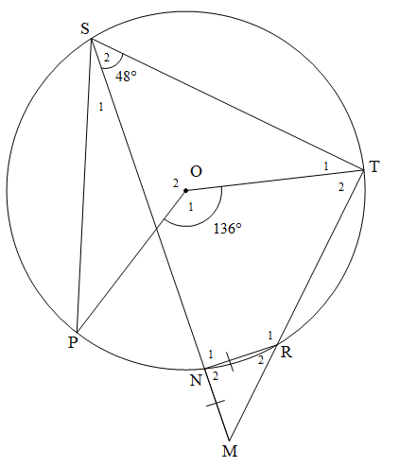

|  |  |  |  |
| --- | --- | --- | --- |
|  | Bepaal, met redes, die grootte van ELK van die volgende hoeke: |  |  |

|  |  |  |  |  |
| --- | --- | --- | --- | --- |
|  | 8.1.1 |  |  | (3) |

|  |  |  |  |  |
| --- | --- | --- | --- | --- |
|  | 8.1.2 |  |  | (6) |

|  |  |  |  |
| --- | --- | --- | --- |
| 8.2 | In die diagram hieronder is PT 'n raaklyn aan sirkel PQR by P.    SR is getrek sodat RS || PT |  |  |

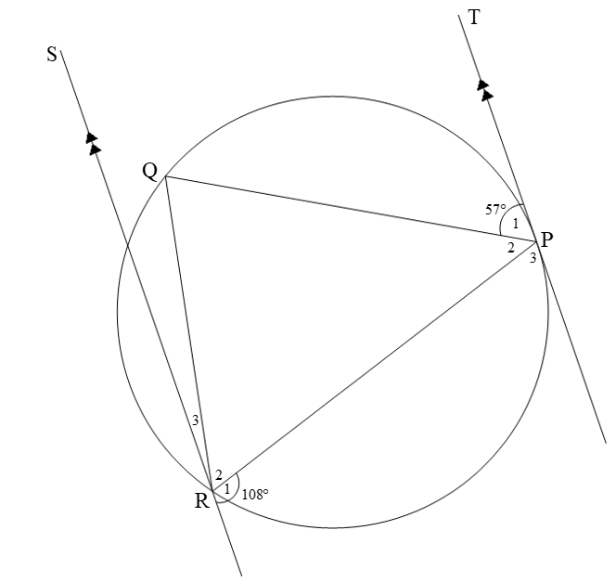

|  |  |  |  |  |
| --- | --- | --- | --- | --- |
|  | 8.2.1 | Bepaal, met redes, die grootte van |  | (2) |

|  |  |  |  |  |
| --- | --- | --- | --- | --- |
|  | 8.2.2 | Toon aan, met redes, dat |  | (4) |
|  |  | |  | **[15]** |

|  |  |  |
| --- | --- | --- |
| **VRAAG 9** |  |  |

|  |  |  |
| --- | --- | --- |
| In ΔRST hieronder is P 'n punt op RS. V en W is punte op RT sodat PV || SW.  PT en SW sny by Q.  W is die middelpunt van VT.  PS = 9 cm, WT = 6 cm, RV = 2 cm en QW = 1,5 cm |  |  |

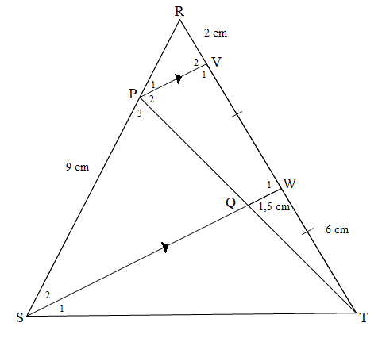

|  |  |  |  |
| --- | --- | --- | --- |
| 9.1 | Skryf die lengte van VW neer. |  | (1) |

|  |  |  |  |
| --- | --- | --- | --- |
| 9.2 | Bepaal vervolgens, met redes, die lengte van RP. |  | (3) |

|  |  |  |  |
| --- | --- | --- | --- |
| 9.3 | Skryf, met 'n rede, die lengte van PV neer. |  | (2) |

|  |  |  |  |
| --- | --- | --- | --- |
| 9.4 | Bewys, met redes, dat Δ RPV ||| Δ RSW |  | (3) |

|  |  |  |  |
| --- | --- | --- | --- |
| 9.5 | Bepaal vervolgens die lengte van SW. |  | (2) |
|  |  |  | **[11]** |

|  |  |  |
| --- | --- | --- |
| **VRAAG 10** |  |  |

|  |  |  |  |
| --- | --- | --- | --- |
| 10.1 | Die prent en diagram hieronder toon 'n fietswiel. Die diagram beeld die sirkelvormige baan van die roterende wiel uit.   * Die radius van die wiel is 40 cm. * AB verteenwoordig 'n koord van die sirkel met middelpunt O. * *h* is die klein hoogte van die segment ten opsigte van koord AB. |  |  |

|  |  |
| --- | --- |
| Vintage Bicycle Wheel Isolated On White Front wheel of a vintage bicycle, isolated on white. Clipping path included (inner edges) bike wheel stock pictures, royalty-free photos & images |  |

|  |  |  |  |
| --- | --- | --- | --- |
|  | Indien die wiel teen 48 omwentelinge per minuut roteer, beantwoord die volgende vrae: |  |  |

|  |  |  |  |  |
| --- | --- | --- | --- | --- |
|  | 10.1.1 | Herlei die rotasiefrekwensie van 48 omwentelinge per minuut na omwentelinge per sekonde. |  | (1) |

|  |  |  |  |  |
| --- | --- | --- | --- | --- |
|  | 10.1.2 | Skryf die lengte van die radius van die wiel in meter neer. |  | (1) |

|  |  |  |  |  |
| --- | --- | --- | --- | --- |
|  | 10.1.3 | Skryf vervolgens die lengte van die middellyn, in meter, neer. |  | (1) |

|  |  |  |  |  |
| --- | --- | --- | --- | --- |
|  | 10.1.4 | Bepaal vervolgens die omtreksnelheid van 'n punt op die omtrek van die wiel, in meter per sekonde. |  | (3) |

|  |  |  |  |  |
| --- | --- | --- | --- | --- |
|  | 10.1.5 | Indien dit verder gegee word dat *h* = 8 cm, bepaal die lengte van AB  in cm. |  | (4) |

|  |  |  |  |
| --- | --- | --- | --- |
| 10.2 | Die prentjie hieronder toon 3 ingekamde ratte. Die diagram onder die prentjie beeld die scenario uit.   * Die dryfrat (middelpunt A) het 'n radius van 10 cm, terwyl die kleiner ratte (middelpunt B en middelpunt C) se radiusse 8 cm en 6 cm onderskeidelik is. * Die ratte raak by punte D, E en F. * Punte D, E en F is op die sye van  geleë. * Die gearseerde sektor GBH het 'n sentrale hoek van * Boog DF onderspan 'n sentrale hoek van *θ* |  |  |

|  |
| --- |
| 3 Gear: Over 14,136 Royalty-Free Licensable Stock Photos ... |
|  |

|  |  |  |  |  |
| --- | --- | --- | --- | --- |
|  | 10.2.1 | Herlei  na radiale. |  | (1) |

|  |  |  |  |  |
| --- | --- | --- | --- | --- |
|  | 10.2.2 | Bereken vervolgens die oppervlakte van die gearseerde sektor GBH. |  | (3) |

|  |  |  |  |  |
| --- | --- | --- | --- | --- |
|  | 10.2.3 | Skryf die lengte van AC neer. |  | (1) |

|  |  |  |  |  |
| --- | --- | --- | --- | --- |
|  | 10.2.4 | Bepaal die lengte van boog DF. |  | (5) |
|  |  |  |  | **[20]** |

|  |  |  |
| --- | --- | --- |
| **VRAAG 11** |  |  |

|  |  |  |  |
| --- | --- | --- | --- |
| 11.1 | Die diagram hieronder beeld die prent van 'n muur met 'n gearseerde onreëlmatige, gepleisterde deel uit.   * Die afmetings van die muur: lengte = 3 m en breedte = 2 m * Die onreëlmatige gepleisterde deel het 'n reguit sy van *x* cm, in 4 gelyke dele verdeel, soos getoon. * Die ordinate wat hierdie dele verdeel, is onderskeidelik 1,2 m; 1,15 m; 1,25 m; 1,1 m en 0,9 m. * Die lengte vanaf die vloer tot by die 0,9 m ordinaat is gelyk aan 1,2 m. |  |  |

|  |
| --- |
| How To Hard Plaster a Brick Wall - Bunnings New Zealand |
|  |

|  |  |  |  |  |
| --- | --- | --- | --- | --- |
|  | 11.1.1 | Bepaal die numeriese waarde van *x*. |  | (1) |

|  |  |  |  |  |
| --- | --- | --- | --- | --- |
|  | 11.1.2 | Bepaal vervolgens die wydte van elke gelyke deel. |  | (1) |

|  |  |  |  |  |
| --- | --- | --- | --- | --- |
|  | 11.1.3 | Bepaal vervolgens die oppervlakte van die gearseerde onreëlmatige, gepleisterde deel. |  | (3) |

|  |  |  |  |  |
| --- | --- | --- | --- | --- |
|  | 11.1.4 | Bepaal of R1 700 voldoende sal wees om die res van die muur te pleister as die koste vir die pleistering, materiaal en arbeid ingesluit, R300 per vierkante meter is. |  | (5) |

|  |  |  |  |
| --- | --- | --- | --- |
| 11.2 | Die prent hieronder toon 'n pilaarkap wat bo-op die pilare van grensmure geplaas word. Die diagram langsaan beeld die pilaarkap met die volgende afmetings uit:   * Die piramide-gedeelte het 'n vierkantige basis met lengtes 60 cm by 60 cm en 'n skuinshoogte van 50 cm. * Die reghoekige prisma-gedeelte het dieselfde vierkantige-basis-afmetings as die piramide en 'n hoogte van 10 cm. * *x* cm verteenwoordig die vertikale hoogte van die piramide-gedeelte. |  |  |

|  |  |
| --- | --- |
| Pilaarkap  Pier Cap Natural 300 x 300mm | Totem Timber |  |

|  |
| --- |
| **Die volgende formules mag gebruik word:**  **Buite-oppervlakte van reghoekige prisma**  **Volume van reghoekige prisma**  **Volume van piramide** |

|  |  |  |  |  |
| --- | --- | --- | --- | --- |
|  | 11.2.1 | Bepaal die buite-oppervlakte van die reghoekige prisma-gedeelte van die pilaarkap. |  | (3) |

|  |  |  |  |  |
| --- | --- | --- | --- | --- |
|  | 11.2.2 | Bepaal die waarde van *x*, die vertikale hoogte van die piramide. |  | (2) |

|  |  |  |  |  |
| --- | --- | --- | --- | --- |
|  | 11.2.3 | Bepaal die totale volume van EEN pilaarkap. |  | (3) |
|  |  |  |  | **[18]** |

|  |  |  |  |
| --- | --- | --- | --- |
|  | **TOTAAL:** |  | **150** |

**INLIGTINGSBLAD: TEGNIESE WISKUNDE**

   

, 

   





 , 

, 

 , 

M





InΔABC: 

Oppervlakte van

  



Hoeksnelheid  waar *n* = rotasiefrekwensie

Hoeksnelheid  waar *n* = rotasiefrekwensie

Omtreksnelheid waar *D* = middellyn en *n* = rotasiefrekwensie

Omtreksnelheid  waar = hoeksnelheid en *r* = radius

Booglengte  waar *r* = radius en  = sentrale hoek in radiale

Oppervlakte van 'n sektor  waar *r* = radius, *s* = booglengte

Oppervlakte van 'n sektor  waar *r* = radius en  = sentrale hoek in radiale

 waar *h* = hoogte van segment, *d* = middellyn van sirkel   
 en *x* = lengte van koord

 waar wydte van gelyke dele, 

 ordinaat en *n* = aantal ordinate

**OF**

 waar wydte van gelyke dele,  ordinaat

en *n* = aantal ordinate